Design and Implementation of a Python-Based Messaging Application and Network Traffic Analysis Using Wireshark

Abstract
In this project, the networking concepts are put into practice by creating a Python-based messaging application and network traffic analysis via Wireshark. To support the implementation of the messaging system a client-server architecture was implemented based on the TCP communication to support reliable user authentication, real-time text messaging, and file transfer facility in the system. The application was also enhanced by adding database integration, logging mechanisms and configuration management to make them more usable and also maintainable. Secondly, a packet capture with Wireshark was analyzed to identify the trends of communication, network services and security concerns that might be brought about by the incoming traffic. The findings were useful in developing a list of control measures which can be taken by firewalls to improve the security of the network without meddling with normal communication. The project successfully illustrated the evolution of network applications, analyzing the protocols, researching the traffic and configuring a firewall in a simulation of a realistic networking environment.

Table of Contents
1. Introduction 4
1.1 Background 4
1.2 Project Overview 4
2. Task 1: Python-Based Messaging Application 5
2.1 System Architecture Design 5
2.2 Protocol Specifications 6
2.3 Network Communication Flow 7
2.4 System Implementation 8
2.5 Testing and Functional Validation 10
2.6 Protocol Analysis 14
3. Task 2: Wireshark Analysis and Firewall Configuration 14
3.1 Wireshark Capture Overview 14
3.2 Protocol Hierarchy Analysis 15
3.3 Network Communication Analysis 16
3.4 Application and Service Identification 18
3.5 Security Investigation 19
3.6 Firewall Rule Configuration 21
4. Conclusion 22
References 23
Appendix 25

1. Introduction

1.1 Background
Modern digital communication is based on computer networks which enable the transfer of information between devices in the local and global environment. Many everyday activities and interactions such as online collaboration, cloud computing and instant messaging are services that cannot be done without the efficient network communication to ensure dependable data exchange (Onyema et al., 2022). Messaging applications are now considered to be a vital part of online communication as they enable users to interact in real-time in a form of a text messenger, file sharing and multimedia exchanges. The greater dependency on the use of such apps depict the relevance of communications protocols that are audible as well as network architecture that works.

1.2 Project Overview
This project will be comprised of two practical tasks to show the development of network applications as well as the analysis of network traffic. The former focuses on creation and creation of Python based messaging software with client server design, user authentication, instant messaging and file transfer. The analysis of Wireshark network capture to determine the patterns of communication, applications, and possible security issues and creation of correct firewall rules are the second task. The remainder of this report contains the implementation, analysis, test results, and security results referring to the two tasks (Onyema et al., 2022).

2. Task 1: Python-Based Messaging Application

2.1 System Architecture Design
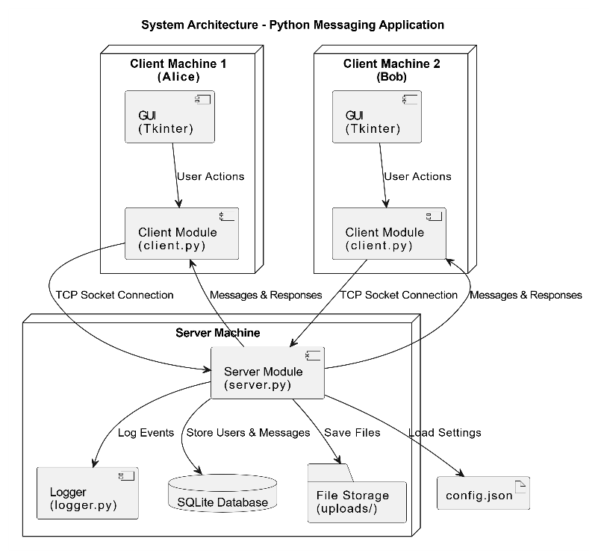
Figure 1: System Architecture of the Messaging Application
The interface that one is granted access to by the client machines is the graphical user interface wherein one can add and remove users, send and receive messages and even share files. Every client connects to the central server via TCP and the central server is in charge of communication requests as well as routing data between connected users (Gaffney et al., 2022). The server is the central part of the application which handles active connections, requests, and coordinates messages delivery.
The server environment incorporates an SQLite database that has stores of user credentials and application data. It is in this database that storage can be persistent, can be used in performing authentication operations as users register and log in. The functionality of file storage is exercised by way of a special uploads directory into which transferred files are temporarily stored awaiting delivery to the recipients. The configuration management is done with a separate configuration file that has the network parameters and the settings of the application (Kayas et al., 2021).

2.2 Protocol Specifications
Messaging application relies on the model of client and server communication model that relies on Transmission Control Protocol (TCP). The client devices in such an architecture are linked to a central system server where users are authenticated, messages sent, connection controlled and files exchanged (Lang et al., 2025). The communication is controlled by a central server which enables effective communication of more than two users at a particular time based on the existing system.
The reason why TCP has been used as a transport protocol is that the application requires a dependable delivery of information and consecutive data transfer. Unlike the connectionless-based protocols, TCP establishes a special connection initially and then begins to exchange information that is always correct and in proper order to the destination. This reliability is particularly vital to messaging systems, where placed, copied, or disorderly messages can have a negative effect on the quality of communication and user experience (Lang et al., 2025).
Python socket programming is adopted to carry out communication between the clients and the server. Sockets enable the data transfer related to file transfers and text messages in addition to authentication requests in the network (Gaffney et al., 2022). The transfer of files is fundamentally the same as communication via TCP protocol. File information, such as the name and size of the file is sent at the beginning and file contents are sent in sequential chunks.

2.3 Network Communication Flow
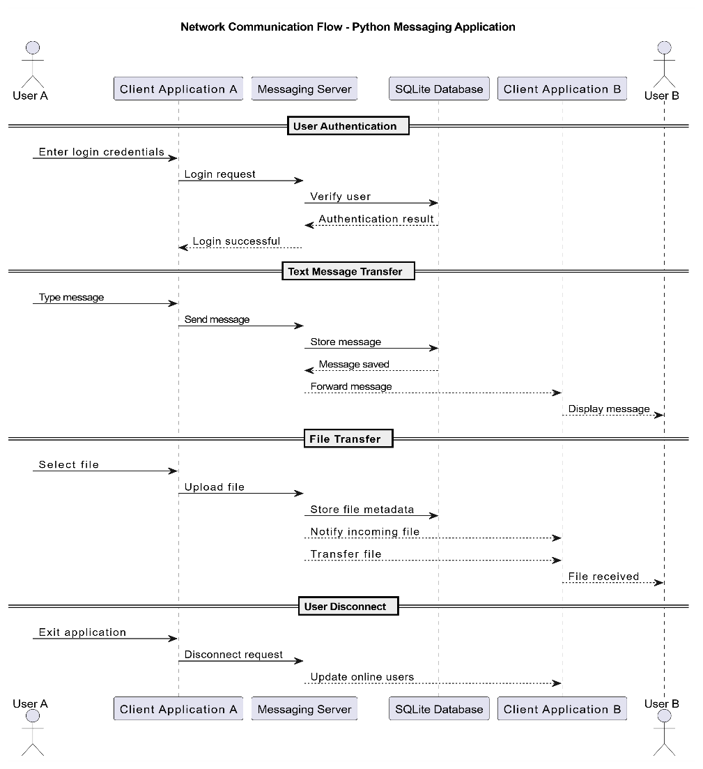
Figure 2: Network Communication Flow of the Messaging Application
It begins with executing a client application by a customer who then gives logins. These credentials are sent to the server through a preexisting TCP connection with authenticity being performed based on the information present on the SQLite database. Upon a successful verification, one is allowed to use the messaging interface where the user is to be available (Patil and Shirbhate, 2024).
After a text message is transmitted, the message is sent to the server, and the information about the recipients is provided by a client (Prammer et al., 2022). The server authenticates the request and logs details needed and sends the message to the recipient. Such a centralized solution guarantees the quality of order and reliability in communications during the time when numerous users are connected.
The file transfer process has a workflow similar with it. Metadata of the files is transmitted then the file contents in random pieces. The user of the file reassembles the file with data sent on the client receiving the file and informs the user of the transfer completion. When a user exits the application, the server receives the request and a disconnection, which notifies the user of the request and removes him or her of the active connection list, and revises the status of connected clients (Prammer et al., 2022).

2.4 System Implementation
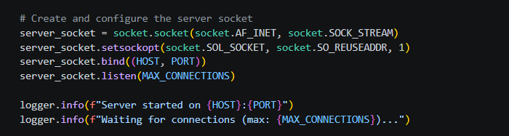
Figure 3: TCP Server Socket Initialization Process
The server module links a TCP socket, binds to a port and a host and waits until a client will enter. This feature is the basis of network communication as it allows the server to receive and process requests of several users. The socket init process uses a steady and dependable connection to ensure that all of the communication is fulfilled.
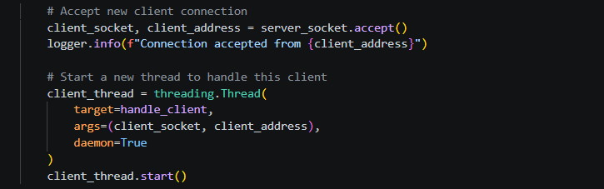
Figure 4: Multi-Threaded Client Connection Handling
The server sets up a special thread to each connected client, to allow multiple users to communicate simultaneously (Schillinger, Huber and Stiller, 2022). Multi-threading also eliminates the chances of one connection pausing the other communication activities and gives multiple users a chance to chat with each other simultaneously. This will be responsive and guarantees the real time interaction within the application.

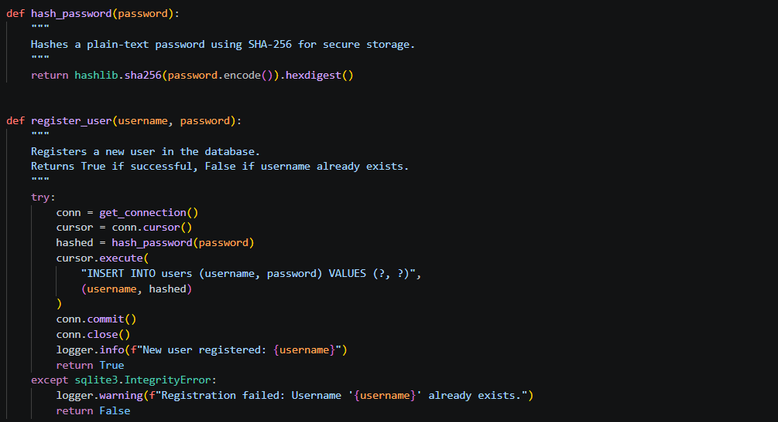
Figure 5: Password Hashing and Authentication Process
SQLite database is authenticated to users to provide secure account control. Passwords will be hashed before being stored so that no sensitive data will be stored uncoded. The credentials provided when logging in, are verified against embedded entries in order to verify identity before being recognized.
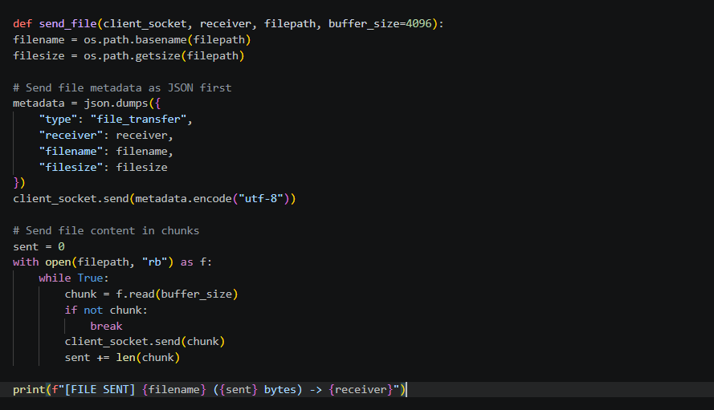
Figure 6: Chunk-Based File Transfer Implementation
It has file transfer functionality, which is done in chunks. The large files are fragmented into small pieces of data and they are exchanged over the TC connection. This provides increased transfer reliability and permits the restructure of files in the other location to be exact.
There are also error handling mechanisms in the application to handle connections failures and other startling situations. The use of logging functionality captures some key activities like user authentication, routing of messages, and file transfers, which are helpful in troubleshooting and monitoring of the system (Lang et al., 2025).

2.5 Testing and Functional Validation
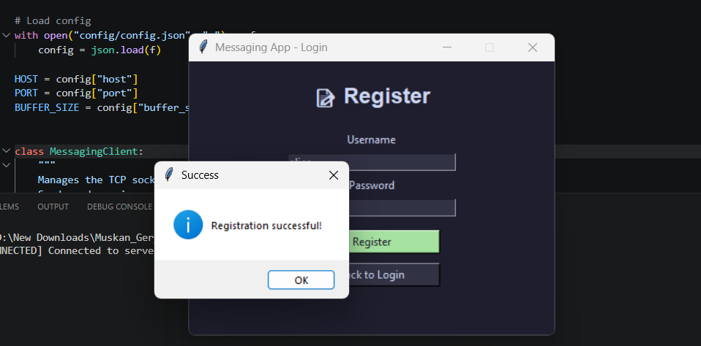
Figure 7: Successful User Registration Process
The testing of user registration revealed that it was possible to create new accounts and store them in SQLite database (Prammer et al., 2022). The user registration interface verified the input of users and sent confirmations where the account creation was successful.
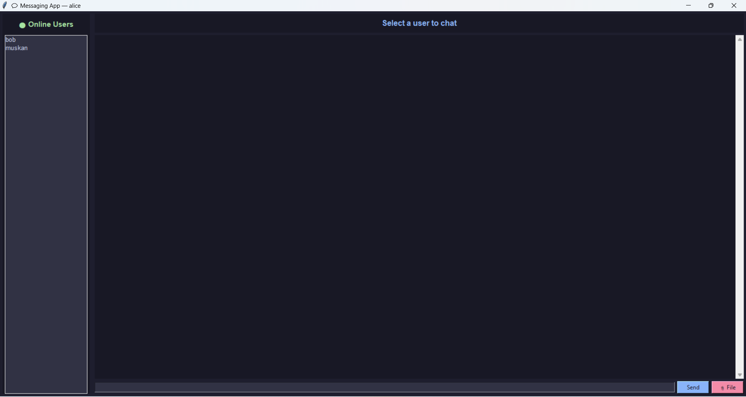
Figure 8: Main Chat Interface After Login
Laws were kept to authenticate users who were registered so they would be in a position to gain access into the application, with valid usernames and passwords. Once authenticated, the chat interface was displayed, which provided access to chat and file-sharing functionality.
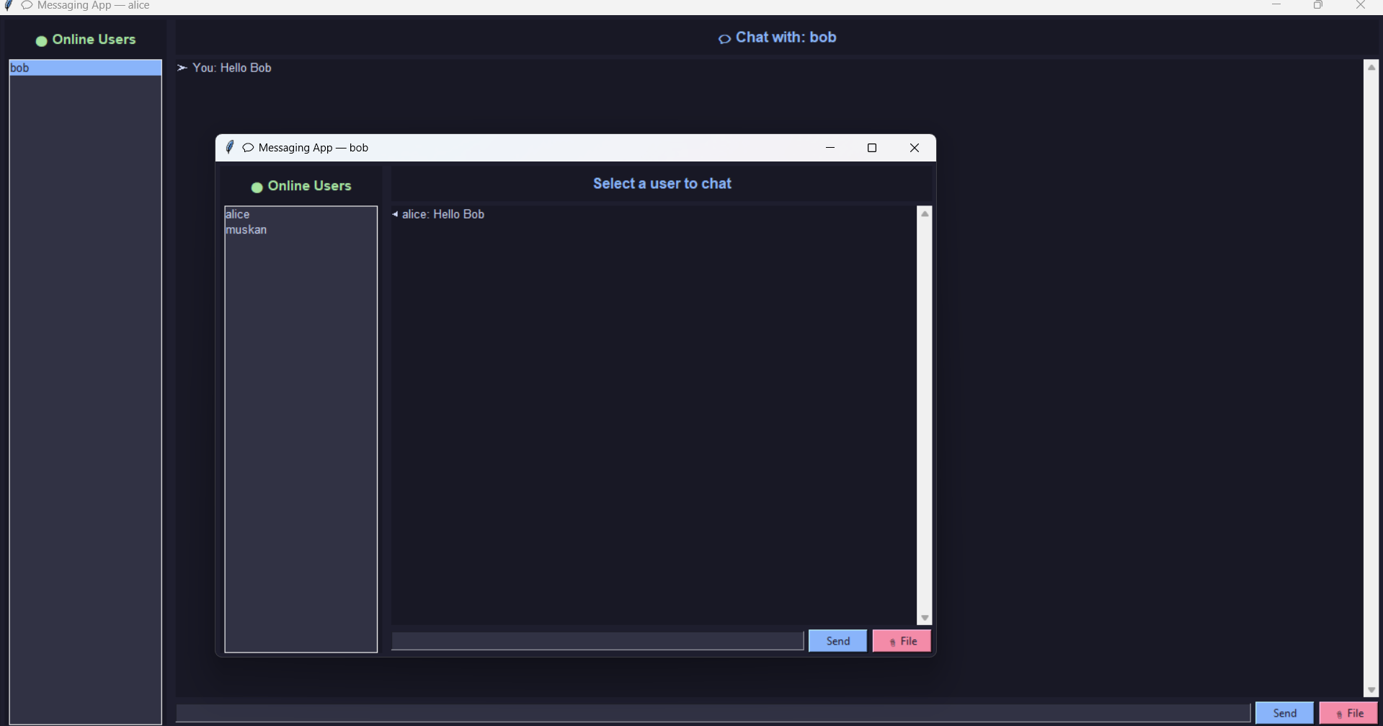
Figure 9: Multiple Users Connected to the Server
Connectivity testing showed that there were varied clients, who could connect with the server at the same time. The server was able to successfully identify that active users were present and keep them maintained without having to disrupt the current communication sessions (Kayas et al., 2021).
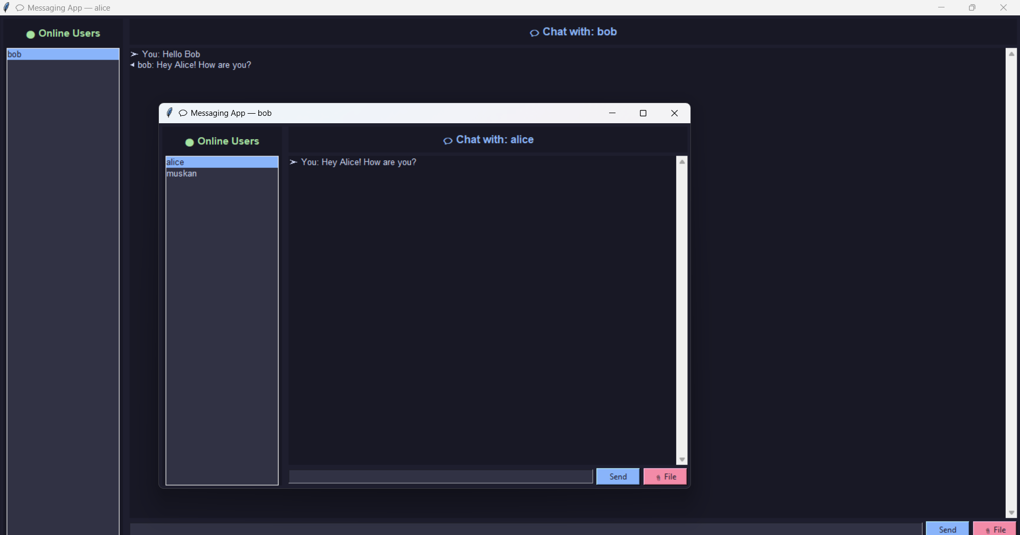
Figure 10: Real-Time Message Exchange Between Users
There was a test of message transmission which proved that text messages were actually being passed on among connected users in an appropriate manner. It demonstrated a successful real time communication by receiving of messages instantly to the recipient equipment.
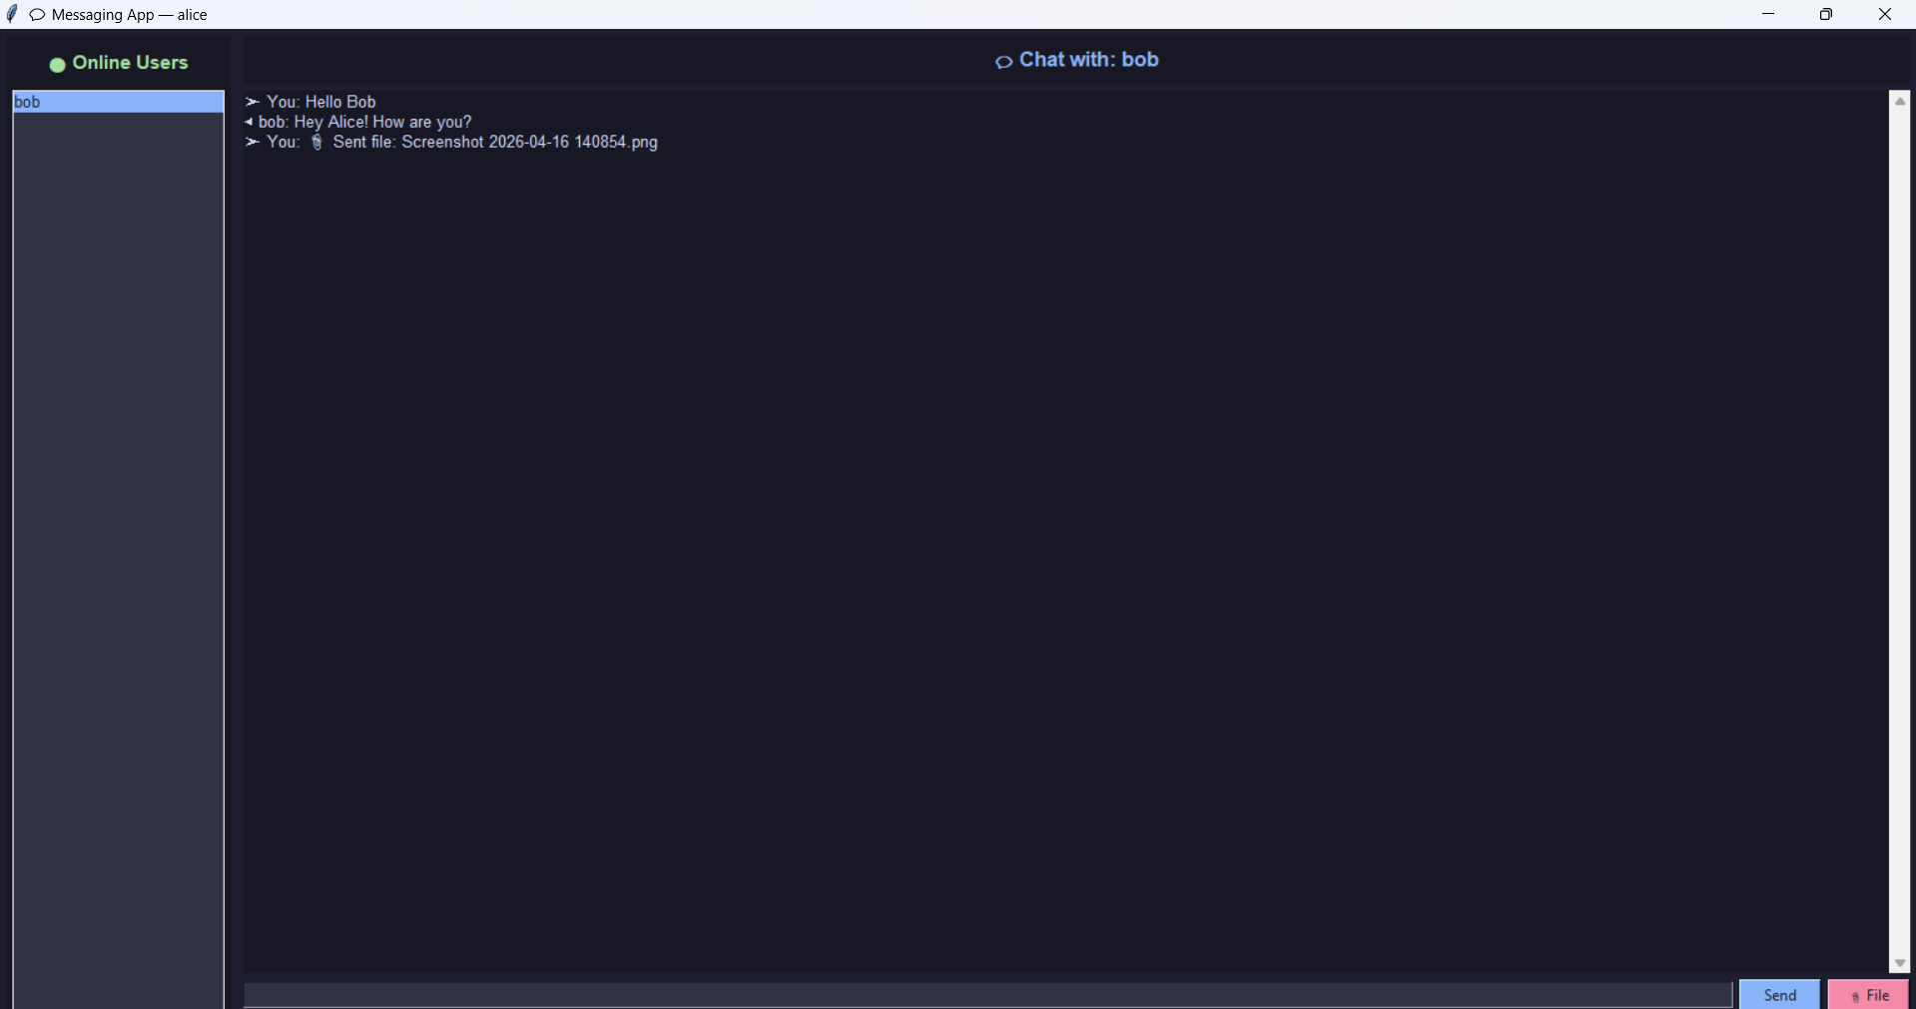
Figure 11: File Transfer Between Client Applications
The ability to send files through files was confirmed by the fact that users were able to exchange files successfully (Zou, 2025). Pictures and documents were also exchanged without corruption and were put together appropriately at where they were received.
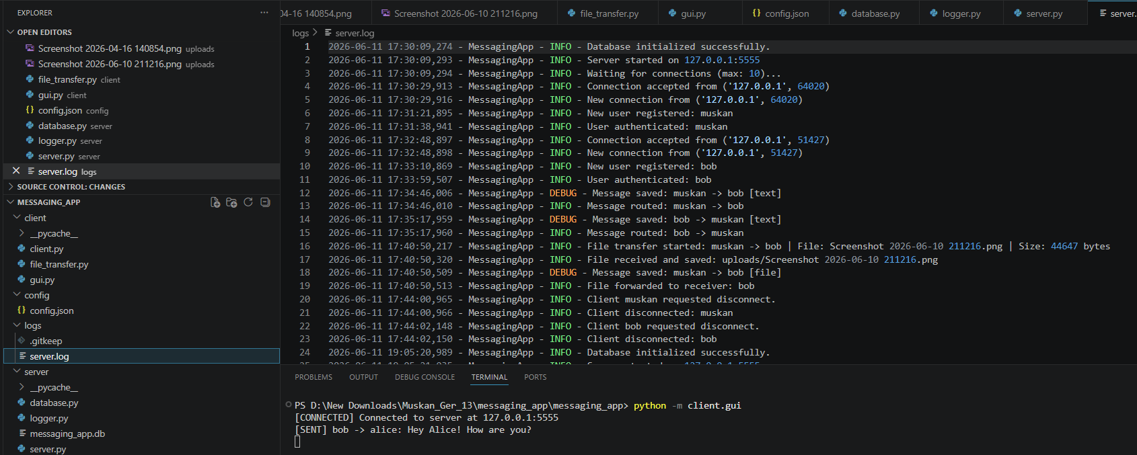
Figure 12: Server Log Activity During Execution
The logging of systems was verified by analyzing the logs. Connection events, authentication requests, message replies and file transfer activities have been recorded successfully that facilitate the monitoring and trouble-shooting processes.
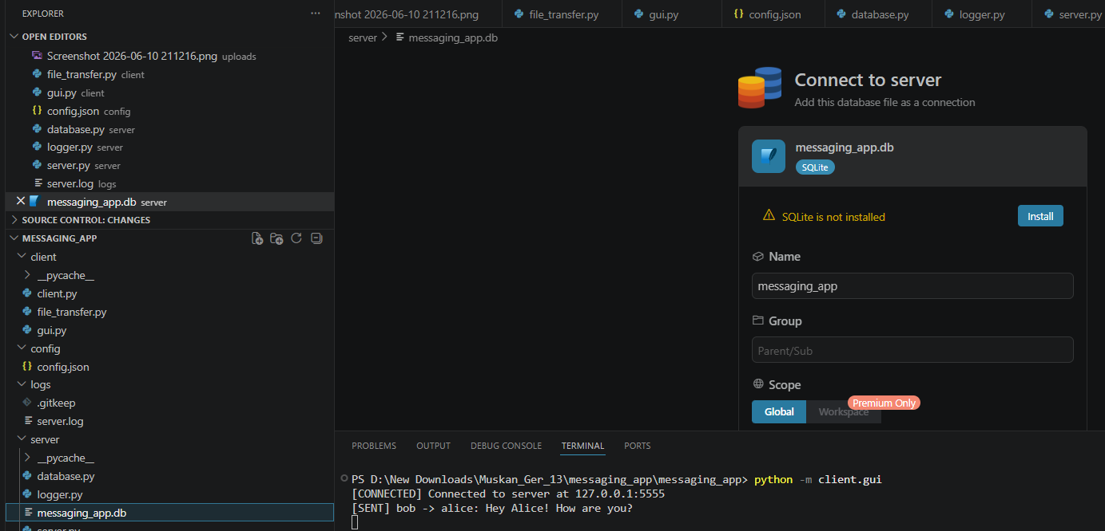
Figure 13: SQLite Database Created by the Application
Connection verification It was confirmed that user credentials along with application data were stored in a database appropriately. The established practical mature and ongoing developability and the main storage of the SQLite database demonstrated reliability in the ongoing storage of data when the application was being used (Zou, 2025).

2.6 Protocol Analysis
The application of TCP as the main communication protocol has been made under the influence of the reliability criteria of the messaging application (Patil and Shirbhate, 2024). The user authentication, file transfer as well as real time messaging processes demand the correct and complete delivery of data and that is why TCP will be an apt choice as far as system architecture is concerned.
TCP communication has a number of benefits. The protocol offers good transmission by use of acknowledgements and retransmission it minimizes the risk of loss of data. Ordered delivery maintains order when messages and file pieces are sent and there is also a built-in error checking to make sure that the information arrives perfectly intact (Gaffney et al., 2022). The features are of particular concern to the messaging apps, where an instance of any lost or corrupt data could have an impact on user experience.
Though it has these advantages, TCP heightens connection establishment, acknowledgements and error recovery overheads. Latency can also be bumped in the protocol as compared to connectionless alternatives such as UDP. However, these weaknesses are also offset by the security and correctness of TCP and that is why it is an appropriate protocol to apply in the messaging platform realized (Patil and Shirbhate, 2024).

3. Task 2: Wireshark Analysis and Firewall Configuration

3.1 Wireshark Capture Overview
The Wireshark capture file was investigated with an aim of investigating the abnormal external network traffic which was observed in the observed environment (Anwar, Abdullah and Pastore, 2021). The data set was made up of thousands of intercepted packets of communication with internal hosts and multiple external systems. This analysis would help identify which protocols are used, the traffic patterns, applications and what security concerns are likely to be raised by observed traffic.

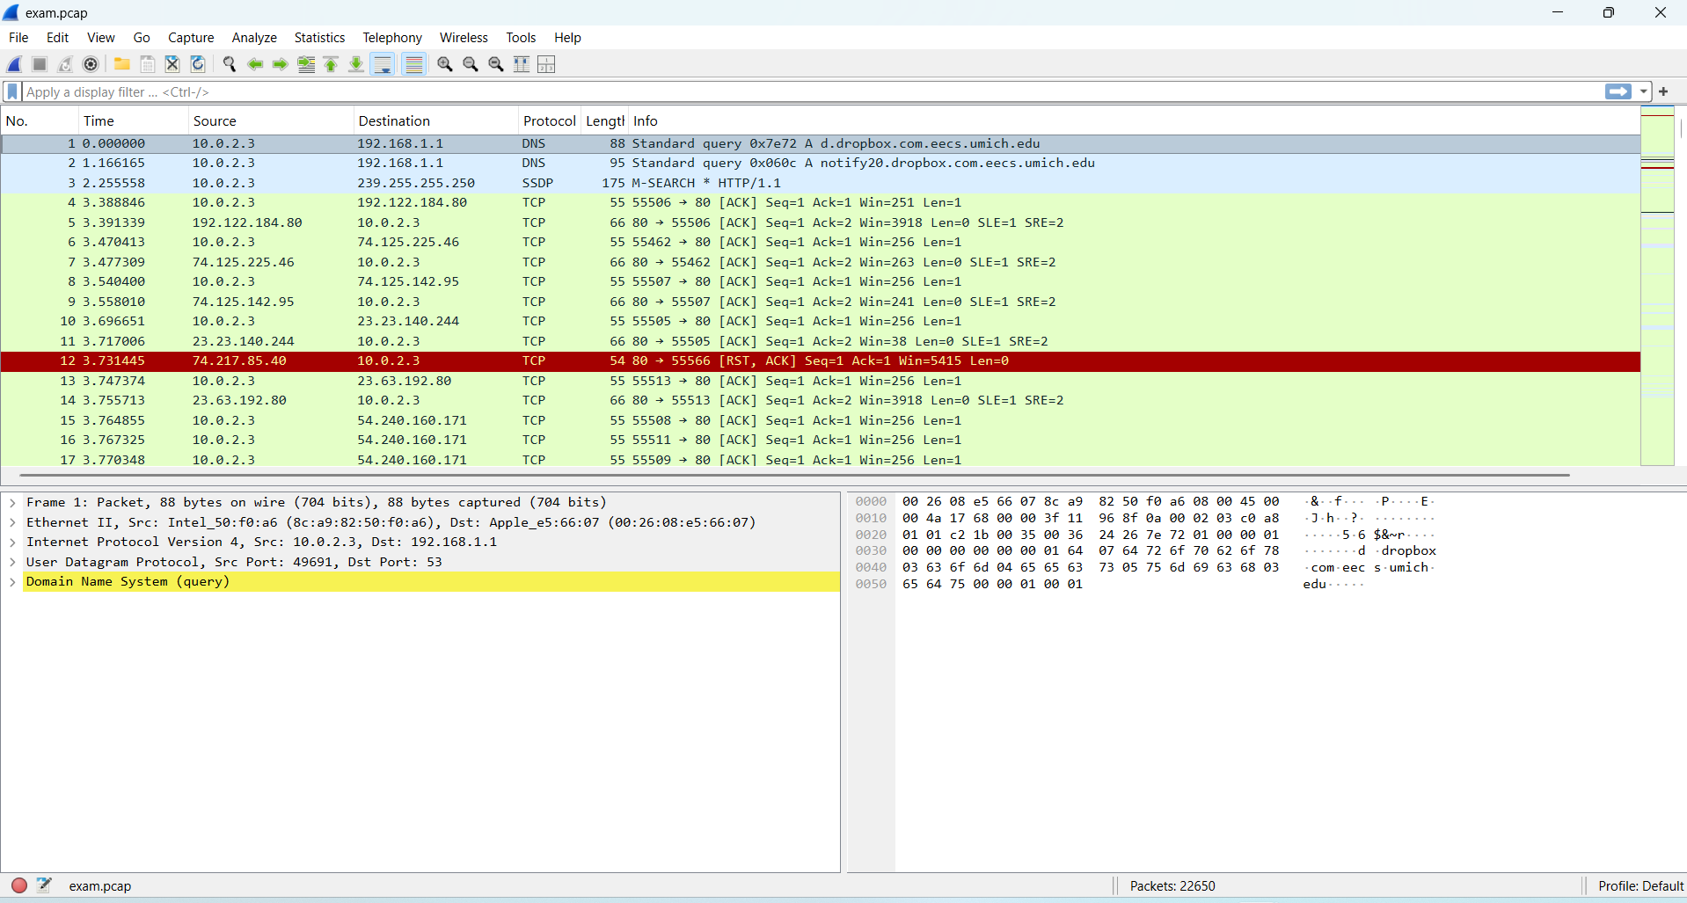
Figure 14: Overview of the Wireshark Capture File
The objective of the investigation was to examine network traffic captured, and make a decision as to whether any suspicious or unauthorized activity occurred. The other objectives were to identify the applications that are generating traffic, network behaviour and communication and the development of an adequate firewall rules that can help curb the exposures to unwarranted outside traffic without affecting the normal network traffic flow (Liu et al., 2022).

3.2 Protocol Hierarchy Analysis
The protocol hierarchy analysis gave me a brief summary of protocols of communication that were in the traffic that was captured (Liu et al., 2022). A large percentage of the packets captured were of HTTP and it indicated web surfing and communication between an application. It was observed that there was DNS activity as well indicating the fact that there are numerous domain name resolution requests made by the network users and applications.
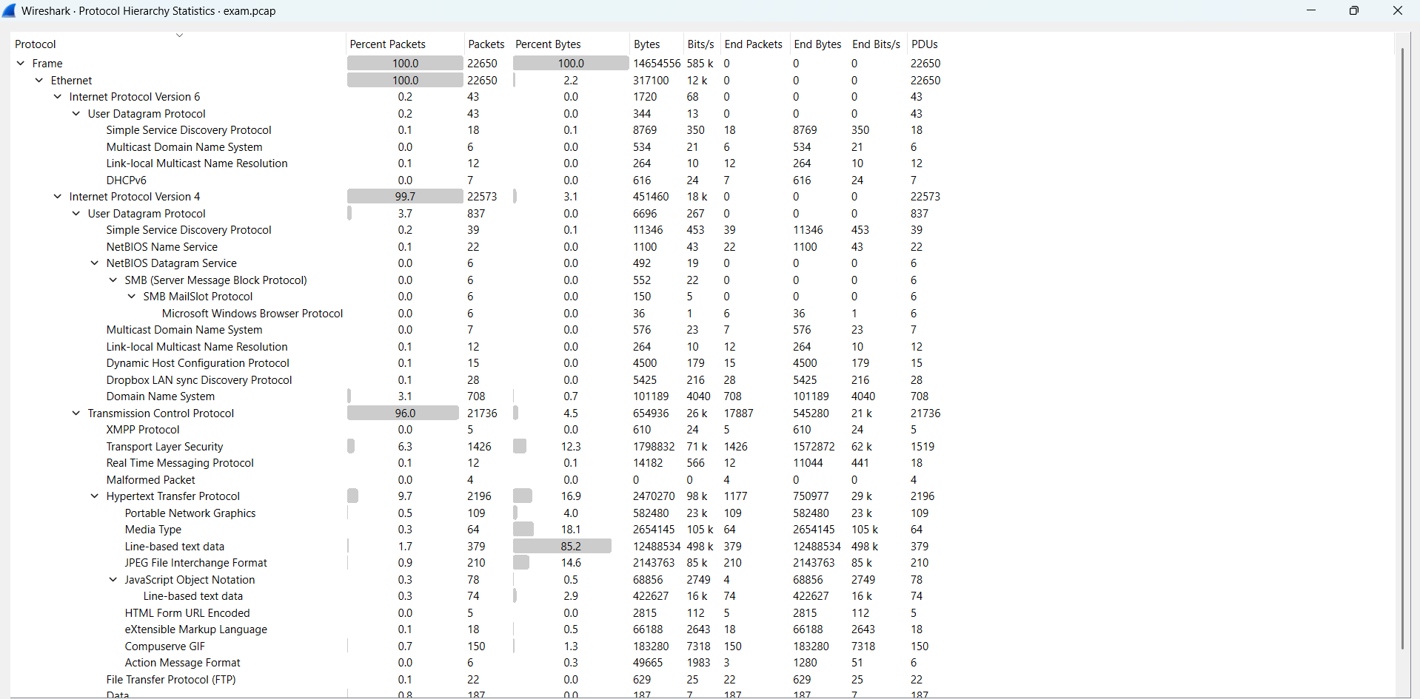
Figure 15: Protocol Hierarchy Analysis of Network Traffic
The existence of an encrypted TLS traffic was combined with the application of HTTP, which means that the secure web services are used. FTP traffic was also minimal in size suggesting that there were repetitive file transfer activities. It was also discovered that SSDP packets are device discovery requests which are employed in the network. Security-wise, it is interesting that there was a HTTP and FTP traffic because neither of the protocols is encrypted, hence, it transmits the data in an unsecured form. Similarly, SSDP packets can disclose the information about devices unless they are redirected to another network and used to push other packet through it (Mabsali, Jassim and Mani, 2023).

3.3 Network Communication Analysis
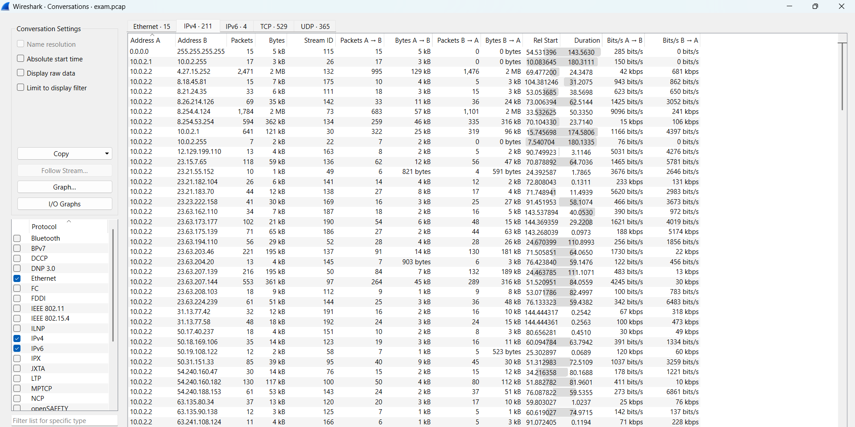
Figure 16: IPv4 Conversation Analysis Between Hosts
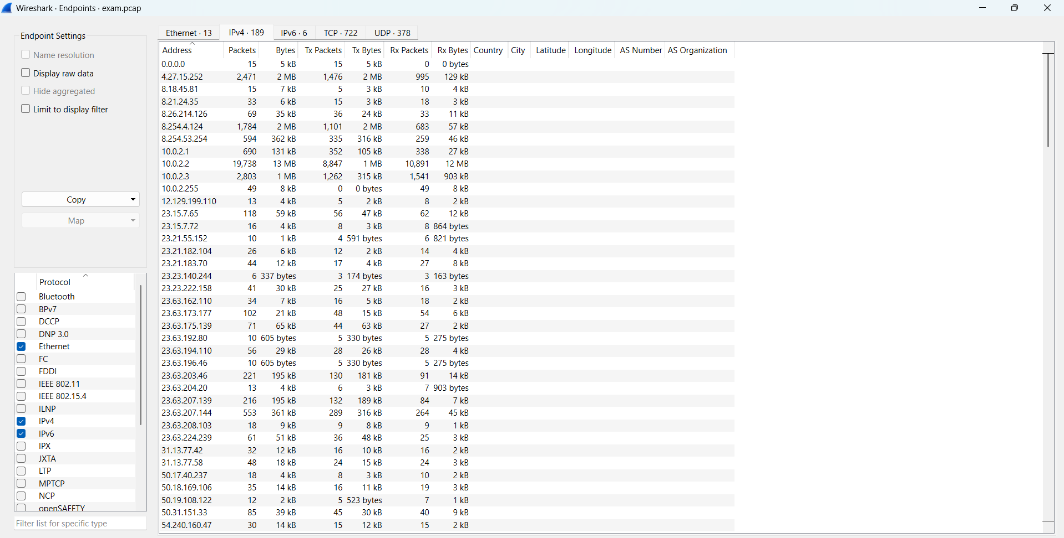
Figure 17: IPv4 Endpoint Statistics of Network Hosts
In the course of the analysis, various internal hosts were identified, and they operated on the same subnet and interact with a significant amount of external systems. The volumes of traffic traffic of some of the external addresses were very high, which implied that they interacted with content delivery circumstance and web service frequently (Oussama Lamdakkar et al., 2024). Communication trend suggested the common activity of the users like browsing, updating of their applications and the cloud services.
End point statistics showed that one default internal host created much more traffic as compared to other devices in the network. This host had numerous paths to other destinations and was the busiest destination during the capture. The observed communication behaviour was a convenient predictor of the usage patterns of networks and was useful to pinpoint the systems that require further research at subsequent levels of analysis (Tuli, 2023).

3.4 Application and Service Identification
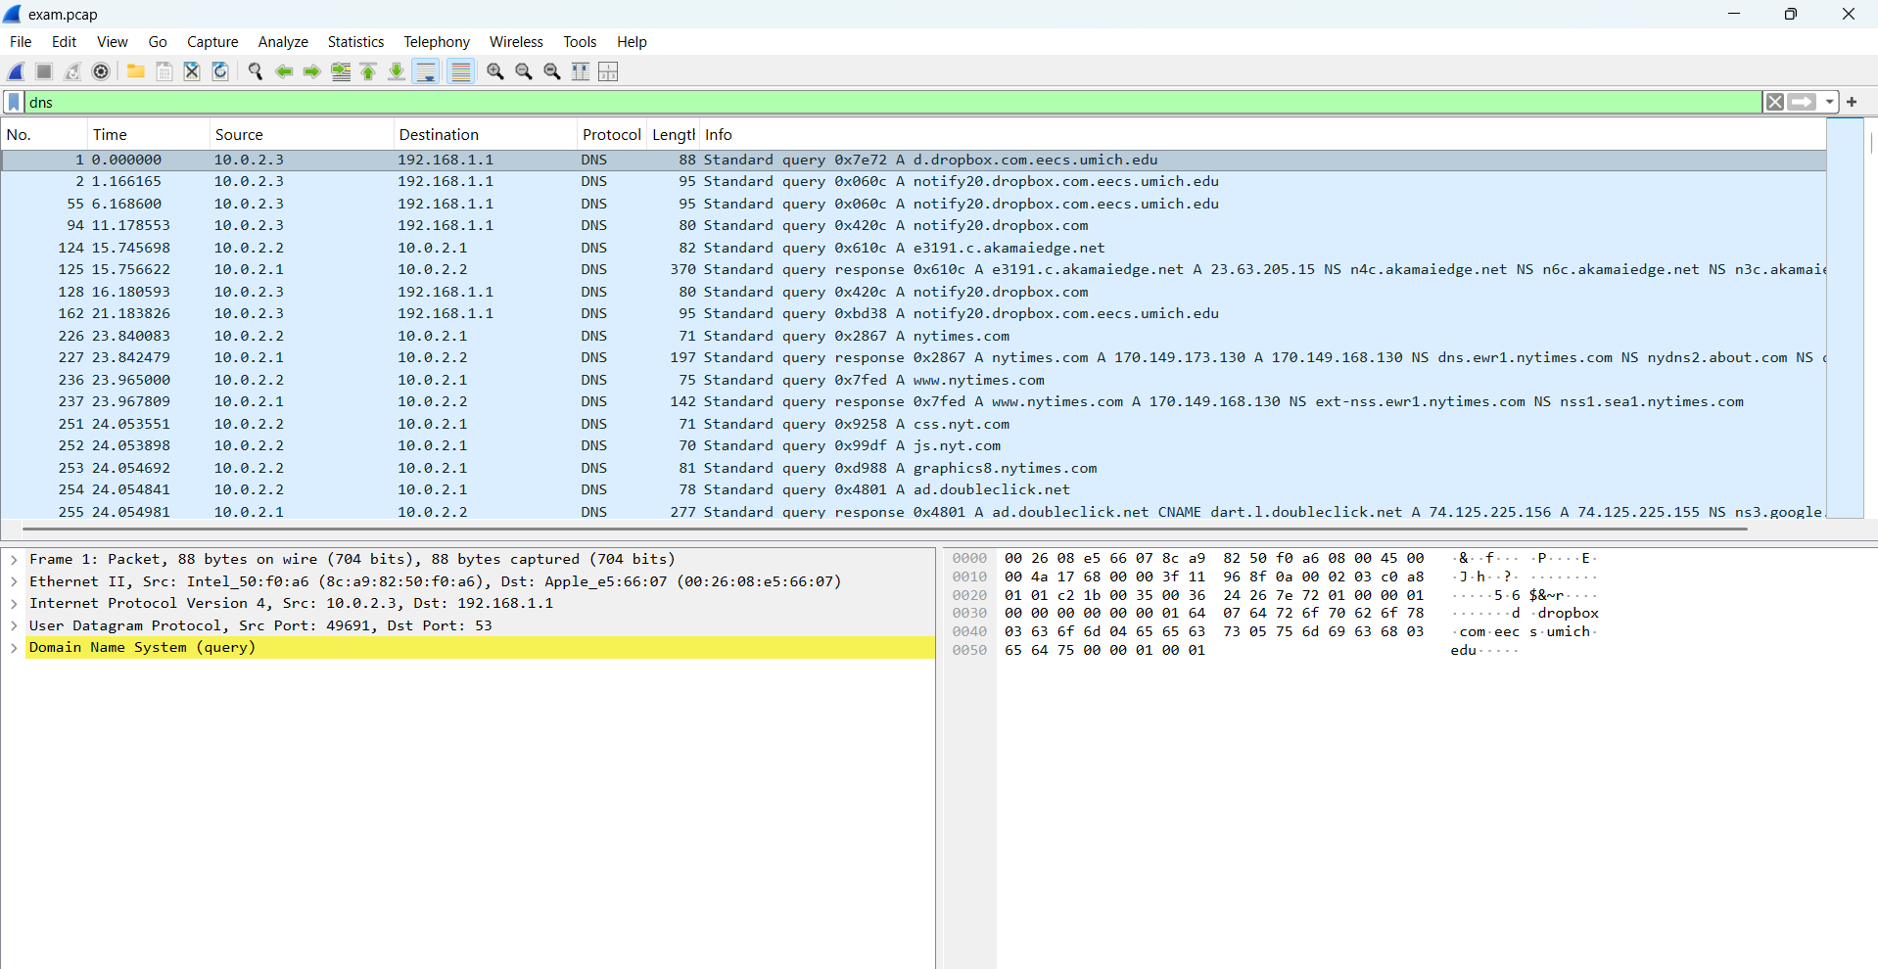
Figure 18: DNS Query Traffic Analysis Results
The use of DNS analogies enabled to identify requests that were related to it using Dropbox services implied that there is active synchronization of cloud-storage in the network context (Liu et al., 2022). Inquiries of news websites and advertisement websites and content delivery networks have been mentioned. The results showed the heterogeneity of services failed by users and revealed the importance of DNS in facilitate application connectivity.
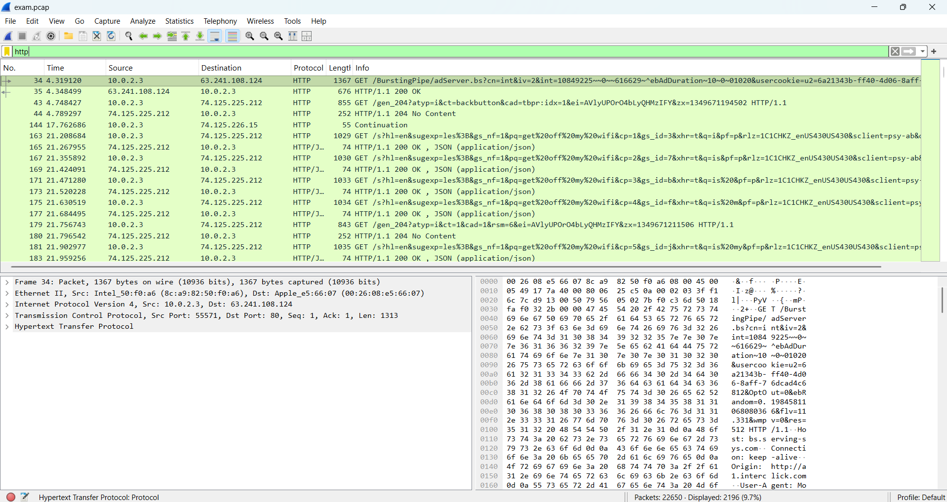
Figure 19: HTTP Traffic Analysis of Web Requests
Analysis of HTTP traffic involved requests that were related to the activity of web browsing and online services. The content delivery network message suggested contacting web-based resources, images and app material on the server stipulated at other geographical sites. These requests were among Google related services and advertising infrastructure depicting common internet shopping behaviour. The analysis of DNS and HTTP had enabled the suitable recognition of the user activity and applications being operated in the network setting visualized (Rana Abu Bakar and Boonserm Kijsirikul, 2023). This data aided in comprehending the general behaviour of networks, as well as determining the security considerations that could arise.

3.5 Security Investigation
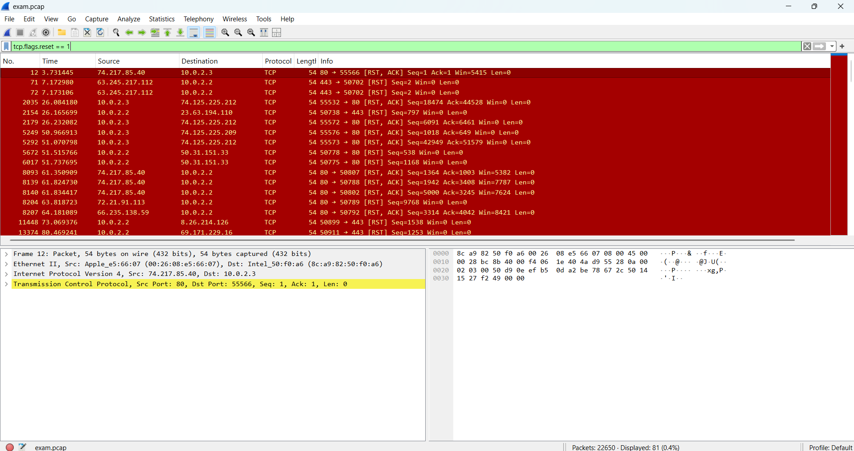
Figure 20: TCP Reset Packet Analysis Results
The TCP reset study revealed that a few connections had been repeatedly broken up unpredictably by a remote host (Anwar, Abdullah and Pastore, 2021). The multiple reset packets represented multiple packets of the same external addresses, which depicted rejected or interrupted attempts of communicating. This behaviour may occur during a typical functioning of the network, yet the frequent resetting action may indicate in certain cases the service constraint, scanning behaviour and oddities of communication.
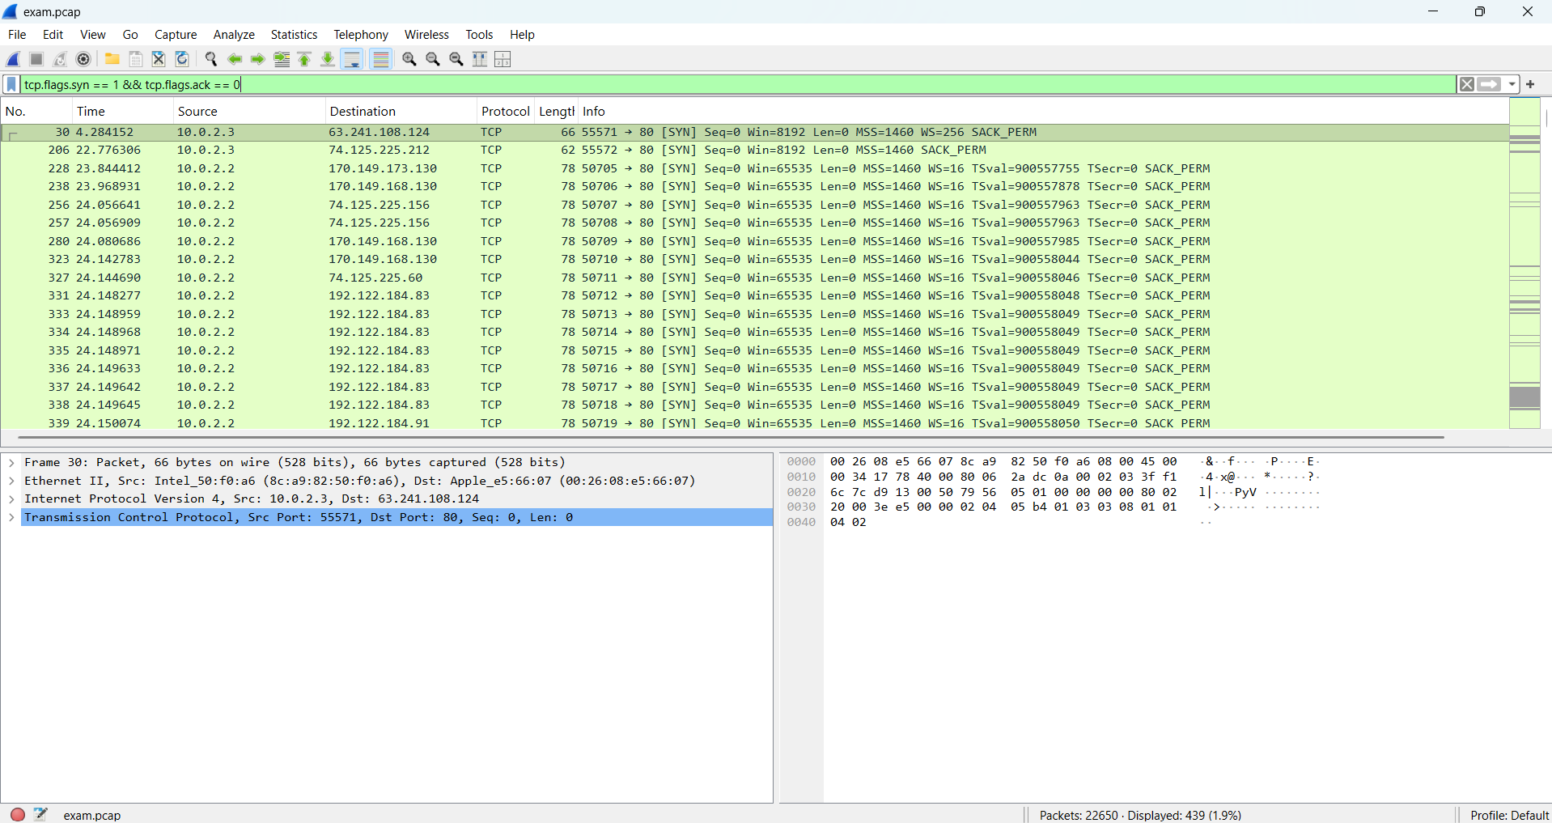Figure 21: TCP SYN Packet Analysis Results
Synthesis of SYN packets indicated that most connection initiation requests were initiated by internal host trying to connect to external services. The trends were normal web browsing behaviour and were not an indication of high inbound scanning behaviour.
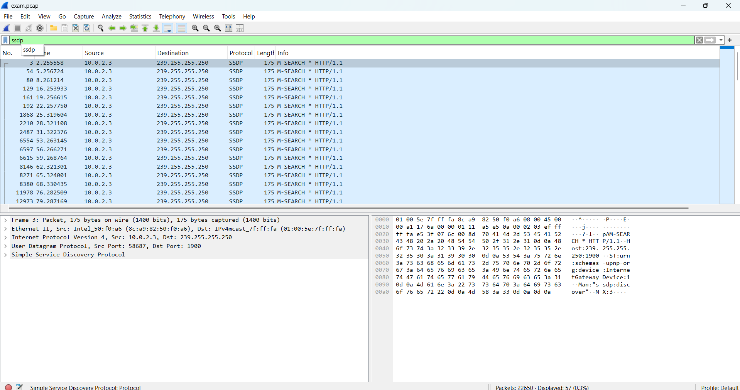
Figure 22: SSDP Traffic Discovery and Analysis
SSDP traffic identity provided a duplicate number of Multicast discovery requests in search of the network devices as well as gateway services. Although this kind of communication is normally acceptable, the open SSDP traffic can reveal information of internal devices. Consequently, avoiding extraneous discovery traffic can contribute to reaching improved network security and a reduced information leakage (Zou, 2025).

3.6 Firewall Rule Configuration
Table 1: Proposed Firewall Rules for Network Protection
HTTPS, HTTP, DNS and existing outbound connections were essential services which should be running on the network which were defined as PERMIT rules (Mabsali, Jassim and Mani, 2023). These policies ensure that the customers are able to utilize web services, perform domain name resolution and utilize cloud based software in a non interrupted manner.
DROP rules were also included to block what may be considered potentially hazardous traffic such as inbound FTP, SMB, NetBIOS, uninvited SSDP communication, and unwanted foreign access. Other blocks were put on traffic which was connected to the unusual connection-reset behaviour which had been encountered during the investigation.
Firewall approach is based on default-deny policy whereby only traffic that is explicitly permitted is to pass through the network boundary. The strategy mitigates the size of an attack, helps prevent access to unwanted services and provides better network security. With the help of a mix of properly chosen permit regulations and restrictive filtering policies, the final firewall setup will offer a good balance between facilitating the usual business processes and enhancing security against any external attacks (Oussama Lamdakkar et al., 2024).

4. Conclusion
This project proved successful in demonstrating that computer networking concepts can be put into a practical format by developing a Python based messaging application and also by analysing network traffic with Wireshark. The messaging system employed a client server architecture with the help of TCP communications that supported the ability to provide a reliable user authentication service, real time messaging and file transfer services. TCP analysis proved it to be a correct selection as it is reliable, has an ordered delivery and error handling qualities. The Wireshark analysis proved to be incredibly beneficial in getting a better understanding of the network communication pattern, expected protocol usage, and security concerns to be made based on the outside traffic. Based on the findings, a series of firewall policies were suggested to provide improved traffic blocking and network security. On the whole, the project met its goals and proved the ability to develop a network application and learn the network security analysis.

References
Gaffney, K.P., Prammer, M., Brasfield, L., Hipp, D.R., Kennedy, D. and Patel, J.M. (2022). SQLite: past, present, and future. Proceedings of the VLDB Endowment, 15(12), pp.3535–3547. doi: https://doi.org/10.14778/3554821.3554842.
Kayas, G., Hossain, M., Payton, J. and Islam, S. (2021). An Overview of UPnP-based IoT Security: Threats, Vulnerabilities, and Prospective Solutions. [online] Available at: https://arxiv.org/pdf/2011.02587.
Lang, L., Hernandez, E., Choudhary, K. and Romero, A.H. (2025). ParquetDB: A Lightweight Python Parquet-Based Database. [online] arXiv.org. Available at: https://arxiv.org/abs/2502.05311.
Patil, O. and Shirbhate, A. (2024). Design and Implementation of a Java-Based Client-Server Application. [online] arXiv.org. Available at: https://arxiv.org/abs/2404.10107.
Prammer, M., Suryadev, S., Rajesh, J., Chen, J. and Patel (2022). Introducing a Query Acceleration Path for Analytics in SQLite3. [online] Available at: https://www.cidrdb.org/cidr2022/papers/p56-prammer.pdf.
Schiller, E., Huber, R. and Stiller, B. (2022). Python-Based TinyIPFIX in Wireless Sensor Networks. Electronics, [online] 11(3), p.472. doi: https://doi.org/10.3390/electronics11030472.
Anwar, R.W., Abdullah, T. and Pastore, F. (2021). Firewall best practices for securing smart healthcare environment: A review. Applied Sciences, [online] 11(19), p.9183. doi: https://doi.org/10.3390/app11199183.
Liu, X., Zheng, L., Helal, S., Zhang, W., Jia, C. and Zhou, J. (2022). A broad learning-based comprehensive defence against SSDP reflection attacks in IoTs. Digital Communications and Networks. doi: https://doi.org/10.1016/j.dcan.2022.02.008.
Mabsali, N.A.L., Jassim, H. and Mani, J. (2023). Effectiveness of Wireshark Tool for Detecting Attacks and Vulnerabilities in Network Traffic. [online] www.atlantis-press.com. doi: https://doi.org/10.2991/978-94-6463-110-4_10.
Oussama Lamdakkar, Ismail Ameur, Mohamed Mbarek Eleyatt, Carlier, F. and Lahcen Ait Ibourek (2024). Toward a modern secure network based on next-generation firewalls: recommendations and best practices. Procedia computer science, 238, pp.1029–1035. doi: https://doi.org/10.1016/j.procs.2024.06.130.
Rana Abu Bakar and Boonserm Kijsirikul (2023). Enhancing Network Visibility and Security with Advanced Port Scanning Techniques. Sensors, 23(17), pp.7541–7541. doi: https://doi.org/10.3390/s23177541.
Tuli, R. (2023). Analyzing Network performance parameters using wireshark. International Journal of Network Security & Its Applications, [online] 15(01), pp.01-13. doi: https://doi.org/10.5121/ijnsa.2023.15101.
Onyema, E.M., Kumar, M.A., Balasubaramanian, S., Bharany, S., Rehman, A.U., Eldin, E.T. and Shafiq, M. (2022). A Security Policy Protocol for Detection and Prevention of Internet Control Message Protocol Attacks in Software Defined Networks. Sustainability, [online] 14(19), p.11950. doi: https://doi.org/10.3390/su141911950.
Zou, Y. (2025). Design and Implementation of Computer Network Security Monitoring System. Journal of Computer, Signal, and System Research, [online] 2(4), pp.63–68. doi: https://doi.org/10.71222/qkantx75.

Appendix
Github Link: https://github.com/Jashandeep2106/messagingapp.git




























